**Q. What is Hacking?**

Hacking is the art or technique of finding and exploiting a security loophole in an infrastructure like a website, a software, a computer, or even a human being, and the artist is called a hacker.

**Q. What does loopholes in a system mean?**

In technical terms, a loophole can be referred to a part of a system which is not properly defined or secured and hence can be exploited to cause unintended things in the system.

**Q. What is Unethical Hacking?**

When a hacker uses his knowledge to steal from or cause damage to other people, it is known as Unethical Hacking. Like stealing, unethical hacking is also a crime and if caught, the thief will be arrested and would be tried in court.

**Q. What is Ethical Hacking?**

When the hacker helps organisations or individuals with finding security loopholes and fixing them with their permission, it is referred to as ethical hacking. And this is legal because you take permission from the system owner and your motive is not to cause harm or steal, but to secure the system.

**Q. What is considered a cyber crime according to Indian Judiciary system?**

The Indian Cyber Laws and the Indian IT act classifies cybercrimes into 2 broad categories. An activity is considered a cyber crime if

* A computer is being used to attack other computers. For example: hacking, virus/worm attacks, DOS attacks, etc.
* A computer is being used as a weapon to commit real world crimes. For example: cyber terrorism, IPR violations, credit card frauds, EFT frauds, pornography, etc.

This basically means that unlawful use of any computer/device is considered a Cyber Crime.

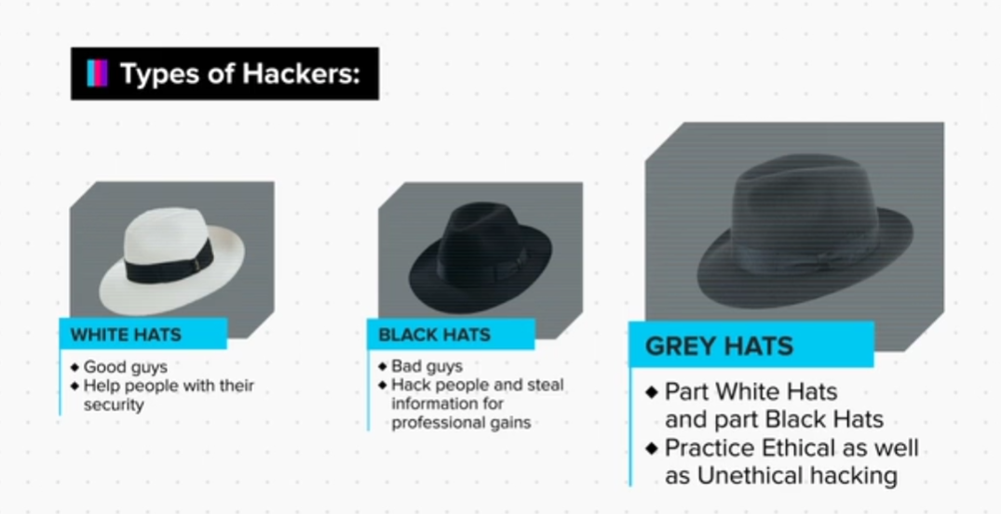

**Exercise**

1. Kevin Mitnick is an American Security expert and called the “World’s most famous hacker”. He was arrested twice for cyber crime and wire fraud; an event quoted as the “manhunt”. Read more and find out such interesting facts about Kevin Mitnick.

2. You may watch the following movies and TV series and learn a trick or two..

Hackers- 1995

Mr. Robot (TV series)

3. Read about some other types of hackers, such as:

Script Kiddies

Elite Hackers

State Sponsored Hackers

Hacktivists

Phreaks

4. Read more about Indian cyber laws and the Indian IT act.

**Summary**

1. Differentiate between ethical and unethical hacking.
2. Have an understanding of what cyber crime is.
3. Differentiate between different types of hackers.